Cisco Systems,Inc.

Packet Tracer - Implement a Small Network

**TTTN2423**

**Switching, Routing and Wireless Essentials**

**(CCNA2)**

**Lab 1**

|  |  |
| --- | --- |
| **NAME** | **MOHAMAD SAIFUL NIZAM BIN ABD AZIZ** |
| **NO. MATRIC** | **A179830** |

Packet Tracer - Implement a Small Network

# Addressing Table

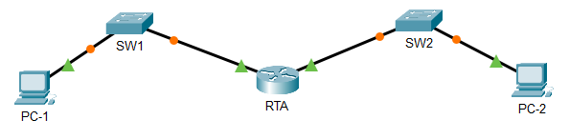

| Device | Interface | Address | Subnet Mask | Default Gateway |
| --- | --- | --- | --- | --- |
| RTA | G0/0 | 10.10.10.1 | 255.255.255.0 | N/A |
| RTA | G0/1 | 10.10.20.1 | 255.255.255.0 |  |
| SW1 | VLAN1 | 10.10.10.2 | 255.255.255.0 | 10.10.10.1 |
| SW2 | VLAN1 | 10.10.20.2 | 255.255.255.0 | 10.10.20.1 |
| PC-1 | NIC | 10.10.10.3 | 255.255.255.0 | 10.10.10.1 |
| PC-2 | NIC | 10.10.20.3 | 255.255.255.0 | 10.10.20.1 |

Blank Line - no additional information

# Objectives

Part 1: Create the Network Topology

Part 2: Configure Devices and Verify Connectivity

# Instructions

## Create the Network Topology

### Obtain the required devices.

* + - 1. Click the **Network Devices** icon in the bottom tool bar.
      2. Click the router icon in the submenu.
      3. Locate the **1941** router icon. Click and drag the icon for the 1941 router into the topology area.
      4. Click the switch entry in the submenu.
      5. Locate the **2960** switch icon. Click and drag the icon for the 2960 switch into the topology area.
      6. Repeat the step above so that there are **two** 2960 switches in the topology area.
      7. Click the **End Devices** icon.
      8. Locate the PC icon. Drag **two** PCs to the topology area.
      9. Arrange the devices into a layout that you can work with by clicking and dragging.

### Name the devices.

The devices have default names that you will need to change. You will name the devices as shown in the Addressing Table. You are changing the display names of the devices. This is the text label that appears below each device. Your display names must match the information in the Addressing Table **exactly**. If a display name does not match, you will not be scored for your device configuration.

* + - 1. Click the device display name that is below the device icon. A text field should appear with a flashing insertion point. If the configuration window for the device appears, close it and try again, clicking a little further away from the device icon.
      2. Replace the current display name with the appropriate display name from the Addressing Table.
      3. Repeat until all devices are named.

### Connect the devices.

* + - 1. Click the orange lightning bolt connections icon in the bottom toolbar.
      2. Locate the Copper Straight-Through cable icon. It looks like a solid black diagonal line.
      3. To connect the device, click the Copper Straight-Through cable icon and then click the first device that you want to connect. Select the correct port and then click the second device. Select the correct port and the devices will be connected.
      4. Connect the devices as specified in the table below.

|  |  |  |  |
| --- | --- | --- | --- |
| From Device | Port | To Device | Port |
| RTA | G0/0 | SW1 | G0/1 |
| RTA | G0/1 | SW2 | G0/1 |
| SW1 | F0/1 | PC-1 | Fastethernet0 |
| SW2 | F0/1 | PC-2 | Fastethernet0 |

Blank Line - no additional information

## Configure Devices

Record the PC addressing and gateway addresses in the addressing table. You can use any available address in the network for PC-1 and PC-2.

### Configure the router.

Open configuration window

* + - 1. Configure basic settings.
         1. Hostname as shown in the Addressing Table.
         2. Configure **Ciscoenpa55** as the encrypted password.
         3. Configure **Ciscolinepa55** as the password on the lines.
         4. All lines should accept connections.
         5. Configure an appropriate message of the day banner.
      2. Configure interface settings.
         1. Addressing.
         2. Descriptions on the interfaces.
         3. Save your configuration. Record the command used.

Ans: copy running-config startup-config

### Configure switch SW1 and SW2.

* + - 1. Configure the default management interface so that it will accept connections over the network from local and remote hosts. Use the values in the addressing table.
      2. Configure an encrypted password using the value in step 1a above.
      3. Configure all lines to accept connections using the password from step 1a above.
      4. Configure the switches so that they can send data to hosts on remote networks.
      5. Save your configuration.
      6. Show and record the MAC Address Table of SW1 and SW2.

Close configuration

### Configure the hosts.

Configure addressing on the hosts. Verify your configuration by pinging all devices in the topology. Explain your verification process and results.

* + - * 1. Firstly, I ping PC-1 with PC-2 and the result is 100%

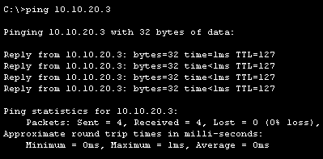

* + - * 1. 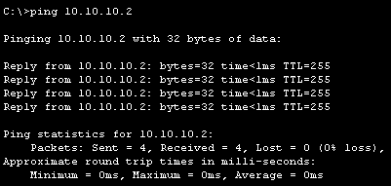Next, I ping PC-1 with SW1 and the result is 100%

Based on the result, all devices in this network are connected and fully functional.

**Reflection Question**

Did you encounter any problems/issues.in your implementation? If yes, explain each problem and how you resolve it?

* The problem that I need to encounter is I forget to set the ip address for PC-1 and PC-2, so I resolved it by set the new ip address for the PC-1 and PC-2.

Show and record the MAC Address Table of SW1 and SW2. Compare them to the recorded MAC Address Tables in Part 2: Step 2f. Are they the same or different? Discuss and explain your answer.

* Their mac addresses are different. Every port on a switch has its own MAC address, which is assigned at the manufacturer. Switches must maintain track of all connected devices' MAC addresses. The switch would not know which port the destination device is connected to if it didn't have the learning function.

SW1: SW2:

End of document